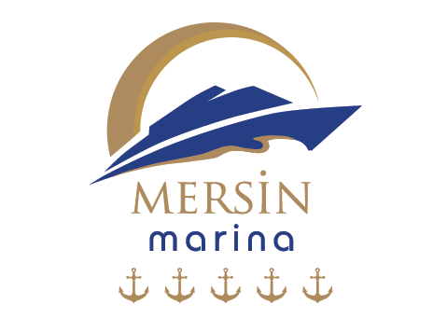

**MERSİN YAT LİMANI İŞLETMELERİ A.Ş.**

**RELATED PERSON APLICATION FORM**

1. **Contact Info of the Applicant:**

**Name:**

**Surname:**

**Phone Number:**

**Email Address:**

**Address:**

1. **Relationship Info**

|  |  |
| --- | --- |
| **Relation with Mersin Yat Limanı İşletmeleri A.Ş.** | |
| **Current Employee**  **Former Employee**  **Years Worked: …………………………………….**  **Customer**  **Ship Owner**  **Other: ………………………………………………….**  **I applied for a job / left a CV**  **(Date: …………………………….)** | **I am the owner of a tenant company**  **I am a former tenant company owner**  **Years as a Tenant: ……………………………….**  **I am an employee of a tenant company**  **Please Specify the Company and Position Information You Work For ………………………………………………………………..**  **I am a former tenant company employee**  **Please Specify the Company and Position Information You Work For …………………………………………………………………** |

1. **Please specify your request within the scope of the Personal Data Protection Law in detail:**

**……………………………………………………………………………………………………………………………………………………………………………………………………………………………………………………………………………………………………………………………………………………………………………………………………………………………………………………………………………………………………………………………………………………………………………………………………………………………………………………………………………………………………………………………………………………**

1. **Please choose the method by which we will notify you of our response to your application:**

**I want it to be sent to my address.**

**I want it to be sent to my e-mail address.**

(Please be aware that if you choose the email method, we can respond to you more quickly.)

**I want to pick it up by hand.**

(In case of representation by proxy, there must be a power of attorney or a document showing the authority of the authorized person.)

**Important Explanation:**

You have to fill out this form and send a signed copy to our address which **is Eğriçam Mahallesi Adnan Menderes Bulvarı No: 33/T Yenişehir/ MERSİN** by notification (through notary channel, etc., or to the e-mail address with an electronic signature.) This application form, which you have filled out, has been prepared to determine your relationship with **Mersin Yat Limanı İşletmeleri A.Ş.** and to respond to your relevant application completely and accurately, if any, within the legal period.

**Warning:**

Applications must belong to the person. Applications cannot be made on behalf of spouses, relatives, children, etc. Our company reserves the right to request additional documents and information (copy of identity card or driver's license, etc.) for identification and authorization in order to eliminate the legal risks that may arise from unlawful and unfair data sharing and especially to ensure the security of your personal data.